**Aim: Find output resistance, id and region of operation of A Current Mirror.**

Schematic:

1. Calculate output resistance:

First, we plot Id vs frequency and take inverse of that plot. we get output resistance.

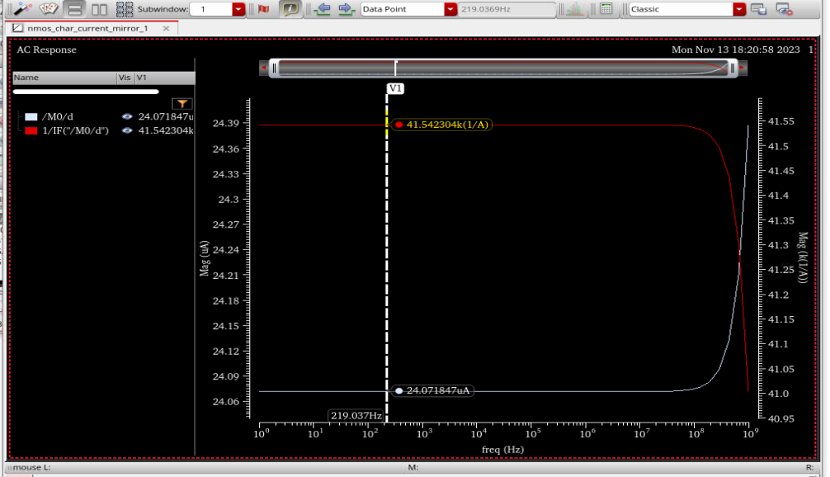

1. Calculate value of Id:

We plot a graph between Id and vds where we get the value of current.

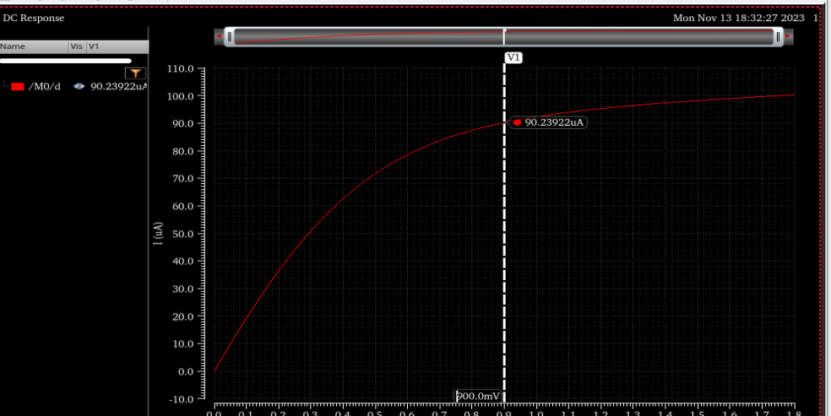

Value of current is not equal to reference value because of some volyage drop across the current source. means Vgs value decreases.

1. Procedure to find region of operation.
2. Setup output
3. Open calculators choose “opt” option
4. List window popup then select mos and find “region” in list window.
5. Decide variable and do parametric analysis